Gradient Descent – An algorithm to minimize f(x) by optimizing its parameters

Scikit-learn (sklearn) provides several algorithms and tools for multi-class classification. One of the commonly used methods for multi-class classification in sklearn is the One-vs-Rest (OvR) strategy. Here's how sklearn implements multi-class classification using this strategy:

One-vs-Rest (OvR) Strategy: In the OvR strategy, sklearn creates a separate binary classifier for each class in the dataset. For example, if there are

𝑛

n classes, sklearn trains

𝑛

n binary classifiers, where each classifier is trained to distinguish one class from all the others.

There is one more technique called One-vs-One (OvO)

New values = old value – Learning rate * slope

New values = old value – stepsize

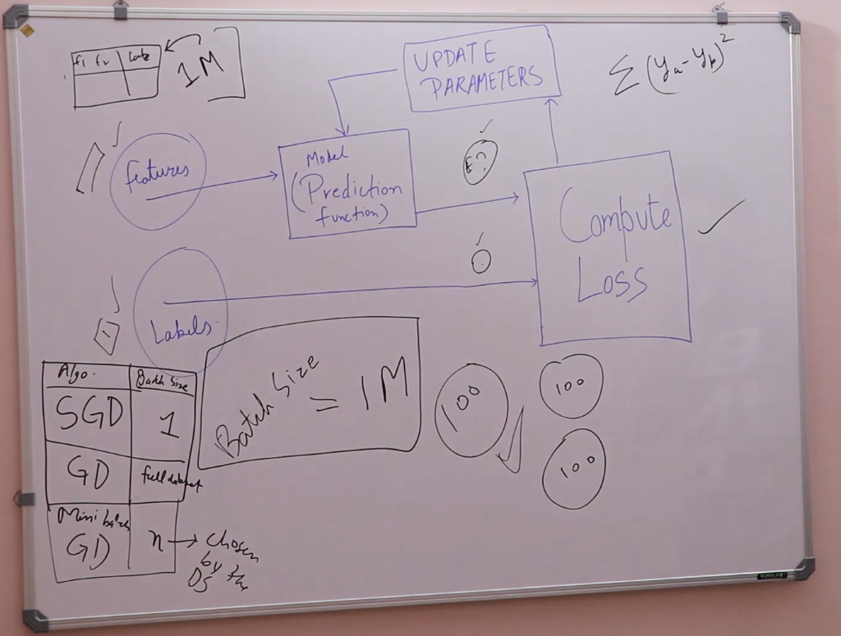

Pandas Is data interpolation tool made over NumPy and integrated with visualization libraries like seaborn

Series, DataFrame is a data structures used in DSA

Axis 1 --- > column I.e fields in database

Axis 0 ----> rows I.e records in database

By choosing examples at random from our data set, we could estimate (albeit, noisily) a big average from a much smaller one. **Stochastic gradient descent** (**SGD**) takes this idea to the extreme--it uses only a single example (a batch size of 1) per iteration.

**Mini-batch stochastic gradient descent** (**mini-batch SGD**) is a compromise between full-batch iteration and SGD. A mini-batch is typically between 10 and 1,000 examples, chosen at random.

A z-score measures exactly how many standard deviations above or below the mean a data point is.

An oscillating loss curve strongly suggests that the learning rate is too high.

Epochs = no of dataset ---> this increases possibility of overfitting hence not recommended

Before proceeding we often scale the data for convinience

become more careful

# about using that column as a feature. That said,

# anomalies in potential features sometimes mirror

# anomalies in the label, which could make the column

# be (or seem to be) a powerful feature.

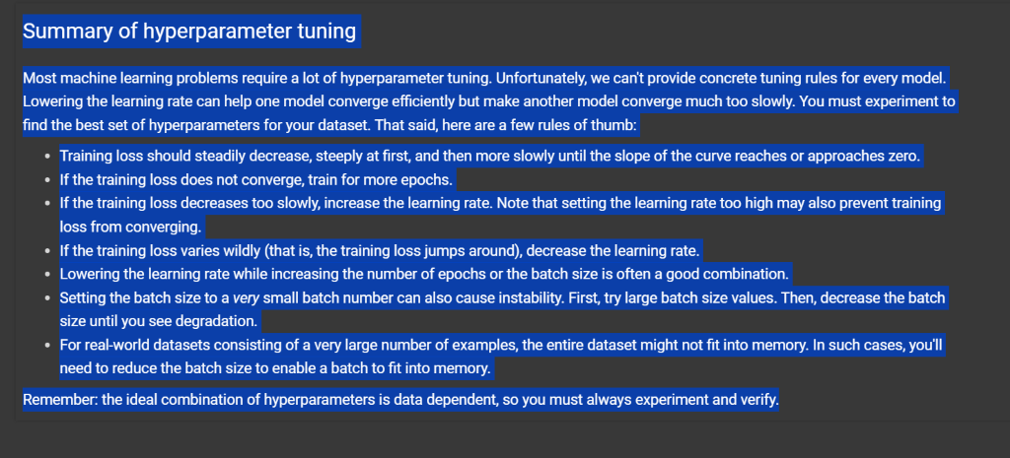

Points for overfitting   
The following three basic assumptions guide generalization:

* We draw examples **independently and identically** (**i.i.d**) at random from the distribution. In other words, examples don't influence each other. (An alternate explanation: i.i.d. is a way of referring to the randomness of variables.)
* The distribution is **stationary**; that is the distribution doesn't change within the data set.
* We draw examples from partitions from the **same distribution.**

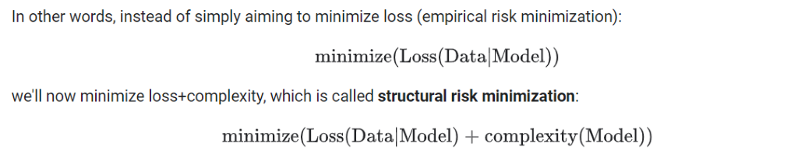

noisy training data set. In this kind of setting, overfitting is a real concern. Fortunately, regularization might help.

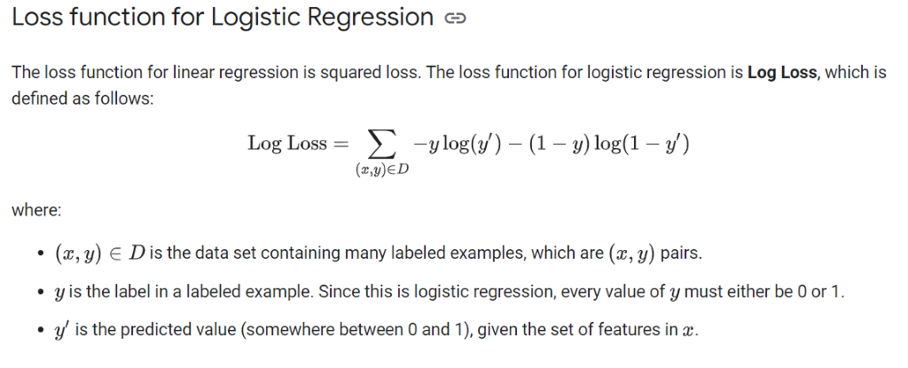

To convert categorical variale into contanious variable we have techinques like one hot encoding,Target encoding, ordinal encoding in feature engineering.

Natural Language processing roadmap

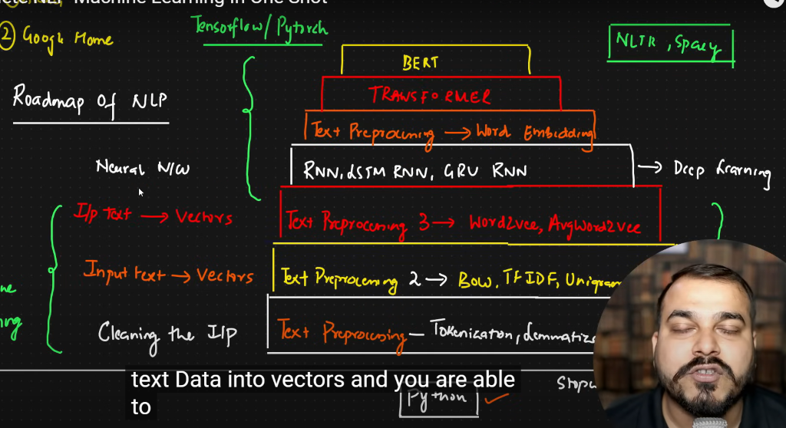

Tokenization – process of converting paragraph(corpus) to sentences(documents)

Stemming - way to convert all words into single word I.e. eaten eating ----> eat , there is some limitations of using this as some words may not interpreted correctly we can rectify this problem by using lemmatization.

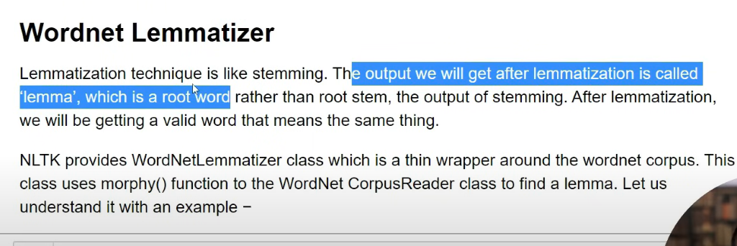

One hot encoding:

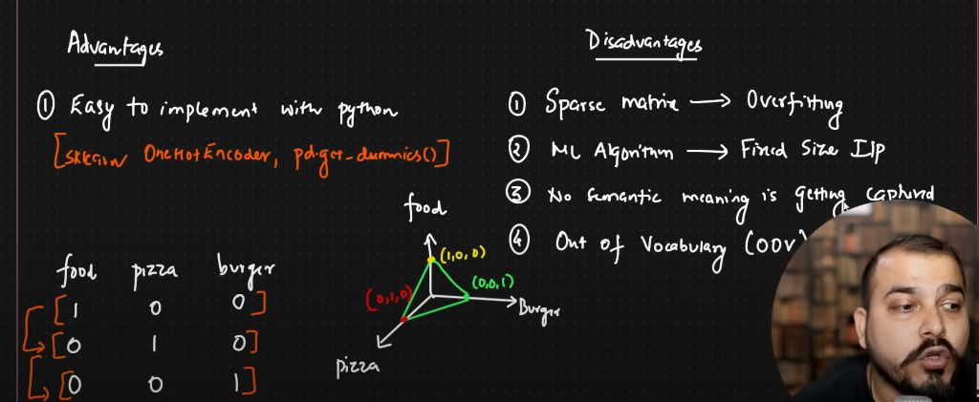

Bag of words:

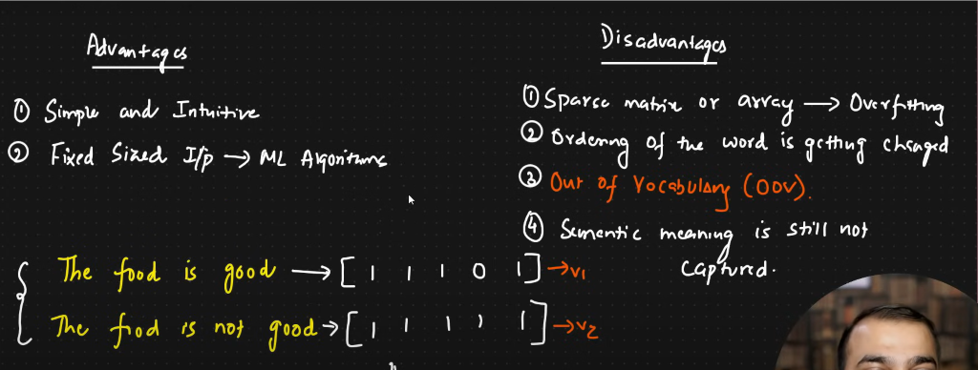

Prefer word2vec model to get vectors

Liberaries for nlp – nltk, spacy

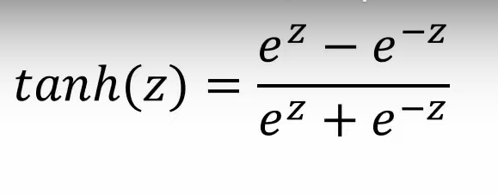

● Zero-Centered: Tanh's output is centered around zero, meaning both positive and negative gradients can flow back through the network during training. This can help address the vanishing gradient problem, where gradients become too small during backpropagation and hinder learning. Sigmoid, on the other hand, can suffer from this issue more readily.

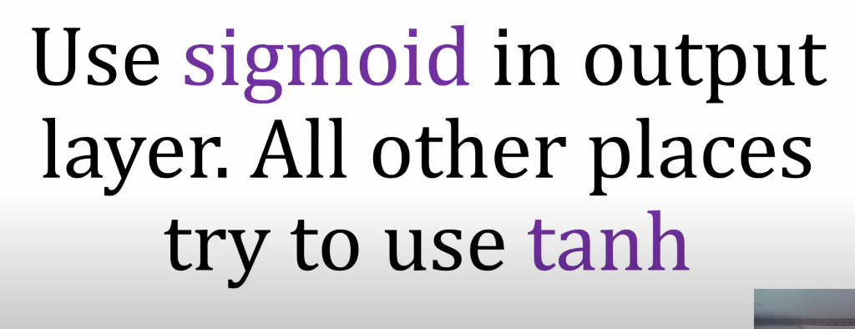

Sigmoid and thanh has vanishing gradiants problems that makes learning process slow

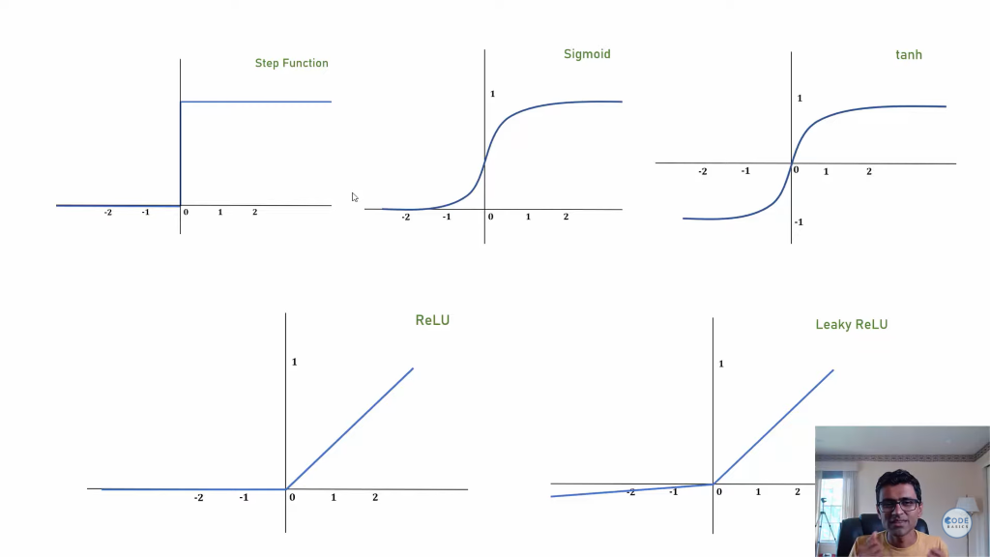

For logistic regressing we use log loss or binary cross entropy instead of mse

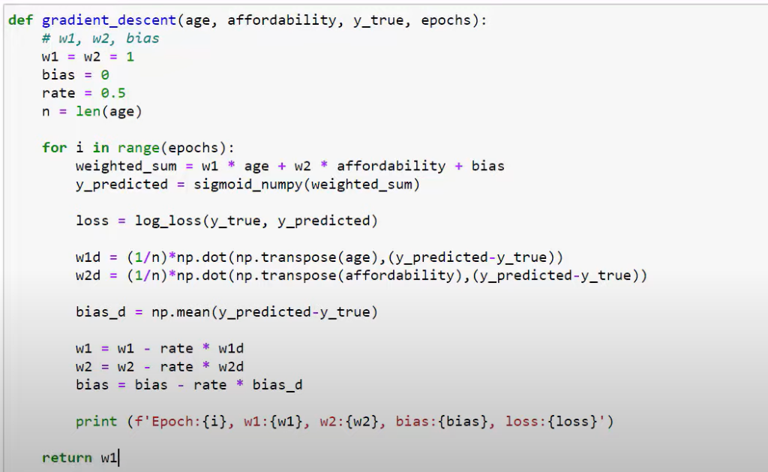

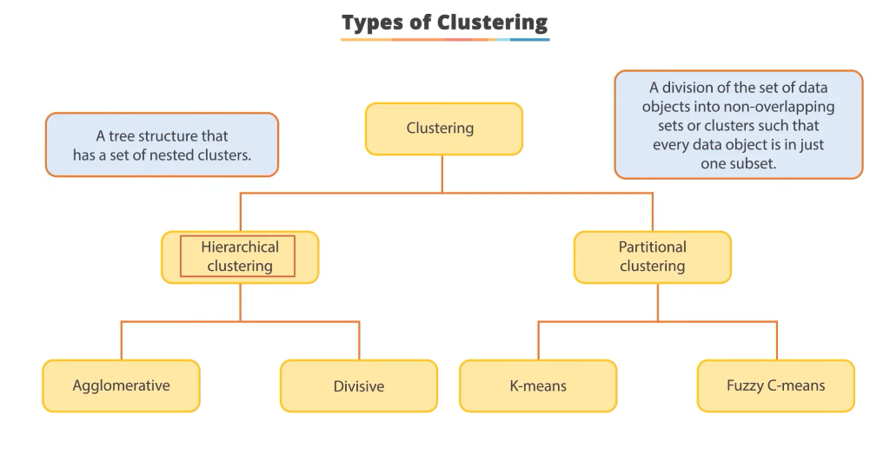

Iloc – integer based indices

subset = df.iloc[row_indices, column_indices]

Clustering:

Kmeans ----> we initilize the centroids(no vary based on situation) and then followed by distance of that centroid from each rows

Will get into the cluster with the smallest distance

Once any record is into the cluster we update centroid position by calculating mean of original and that particlar record

Hierarchical Clustering:

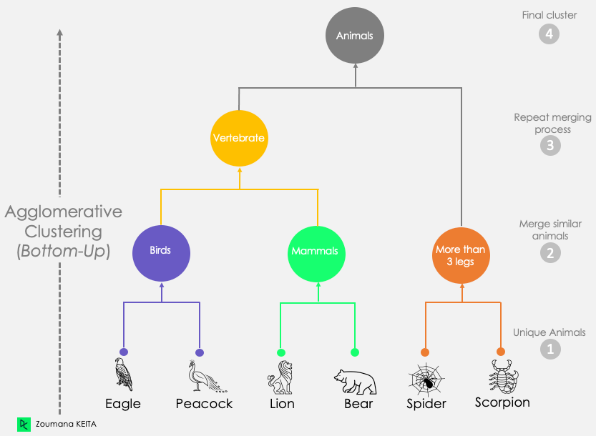

Skypi liberary is used to create dendrogram

How to approach clustering problems

Types of clustering:

* Centroid based
* Density based
* Distribution based

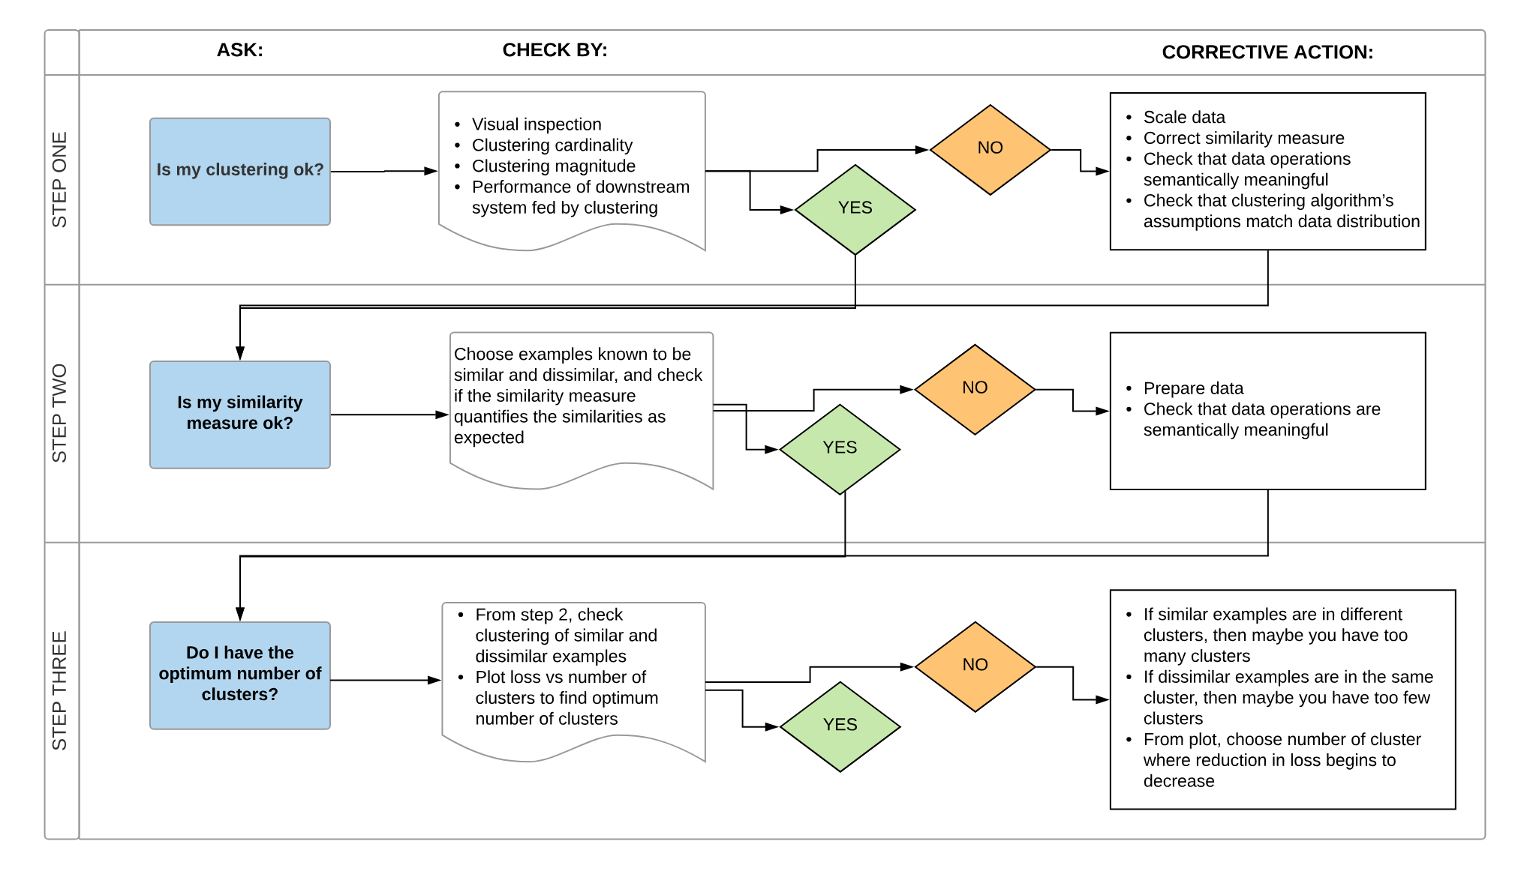

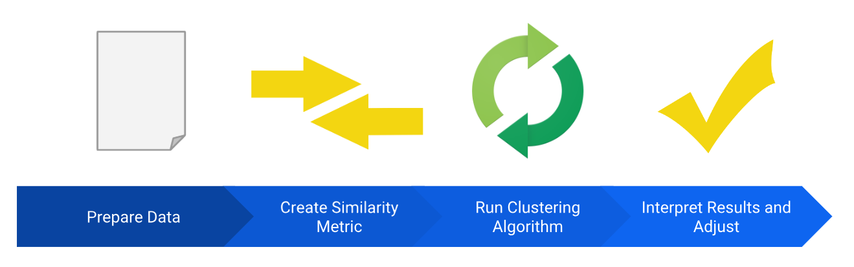

Deep Learning:

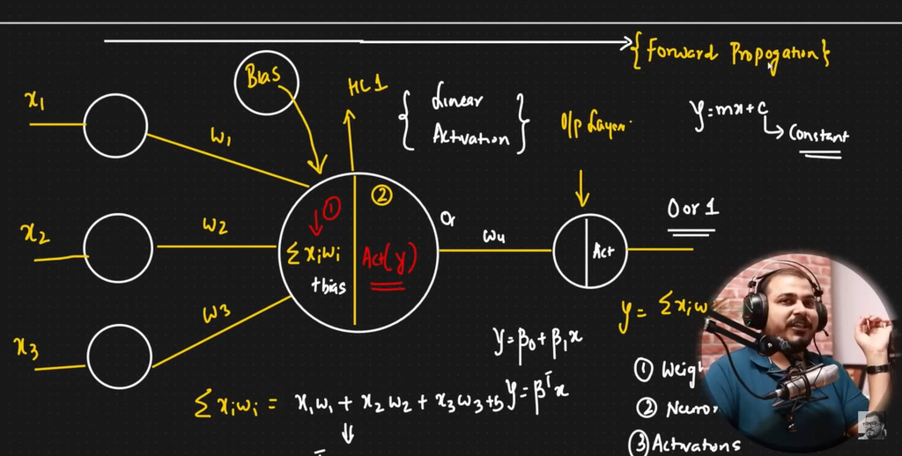

Chain rule:

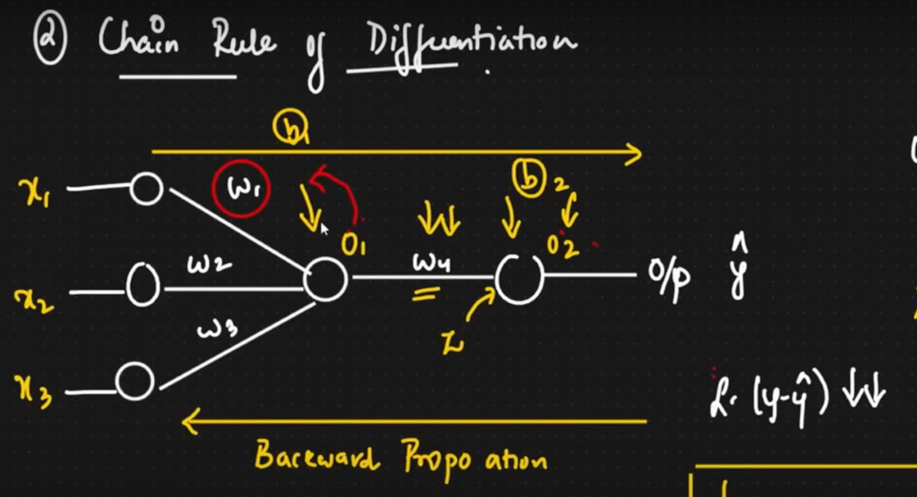

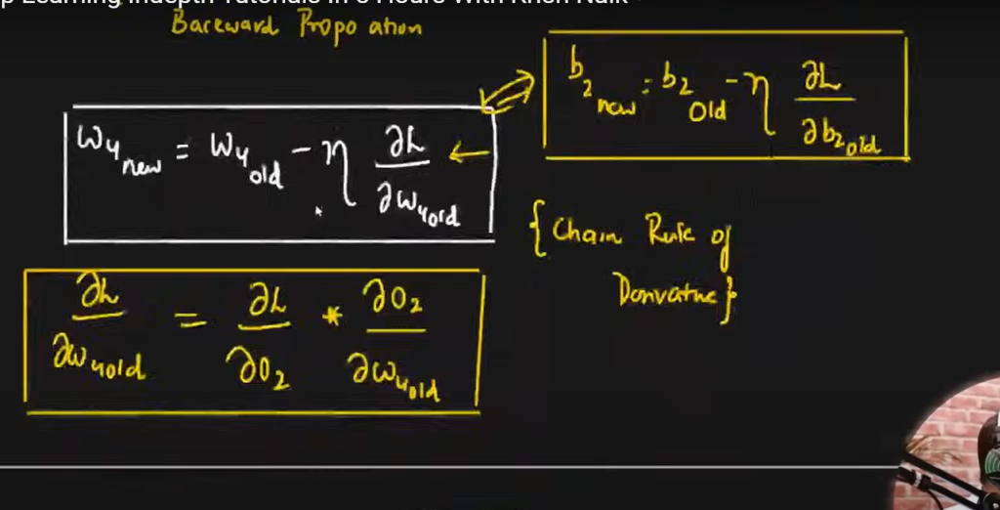

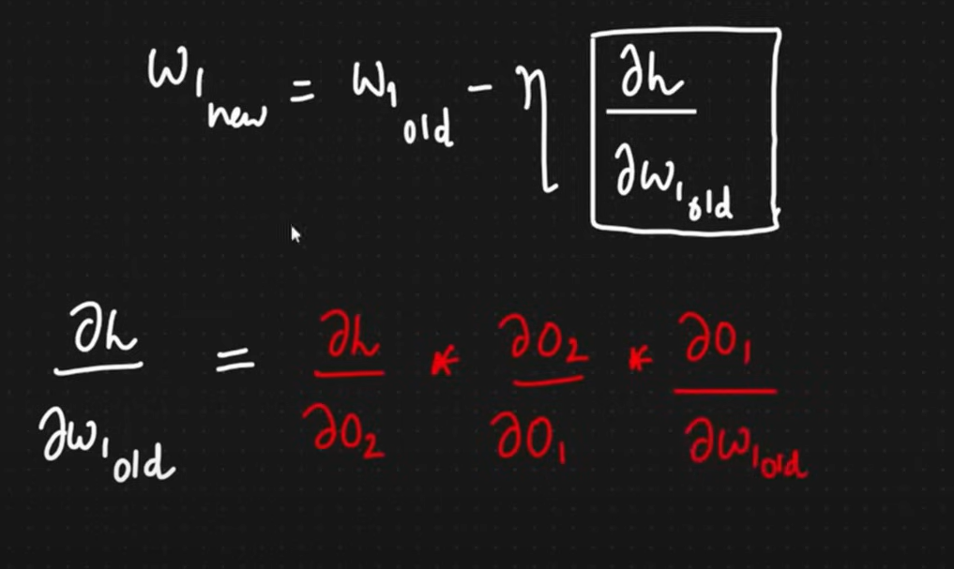

Cause of Vanishing Gradient problem



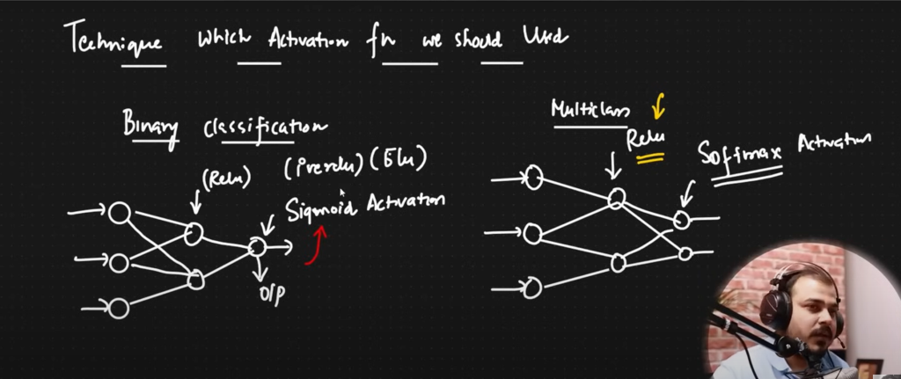

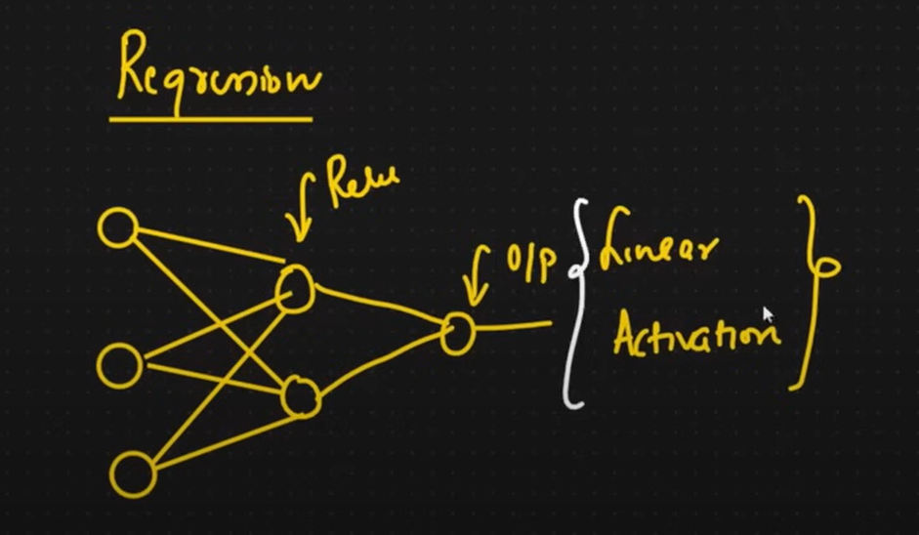

In classification fn

We use cross entropy

1. Binary cross entroy for binary classification
2. Caterigorical cross entropy for multi class classification (we use softmax fn in output layer )

Imp interview question.

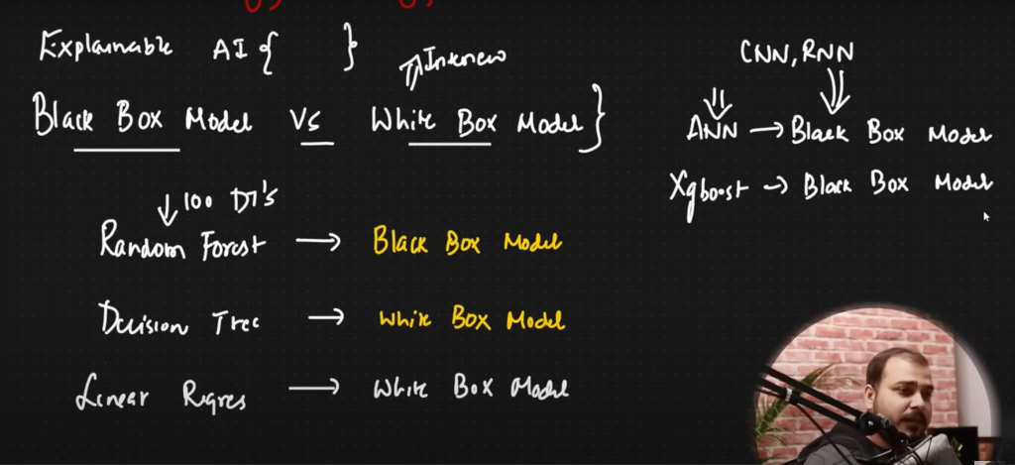

TensorFlow Board is good way to visualize what’s going on in the layers

Resampling methods:

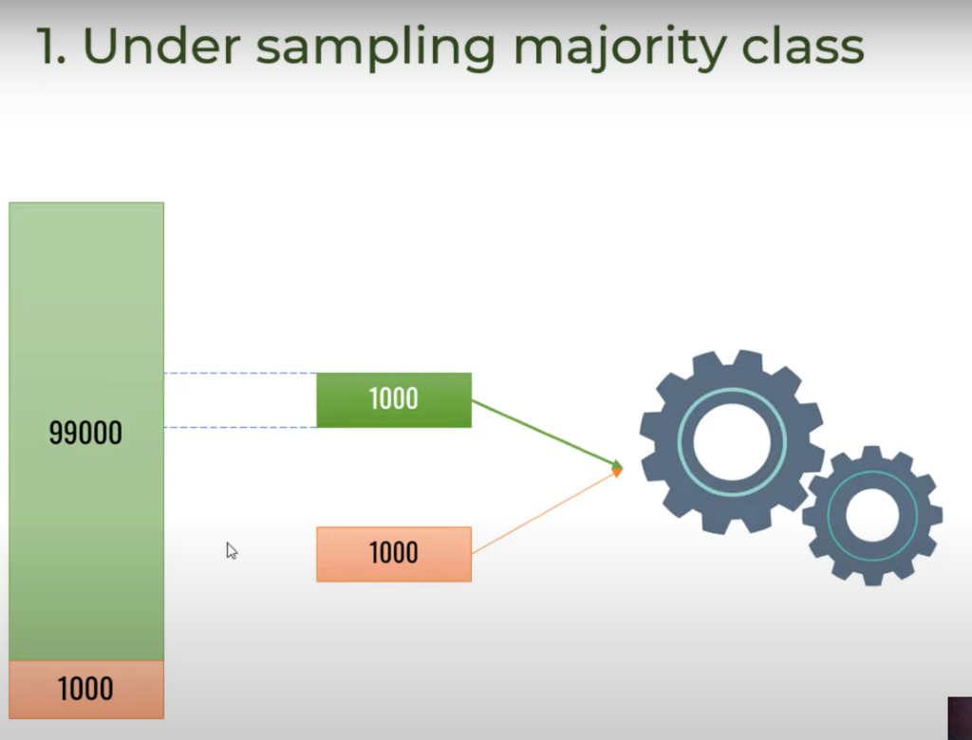

Oversampling by duplicating

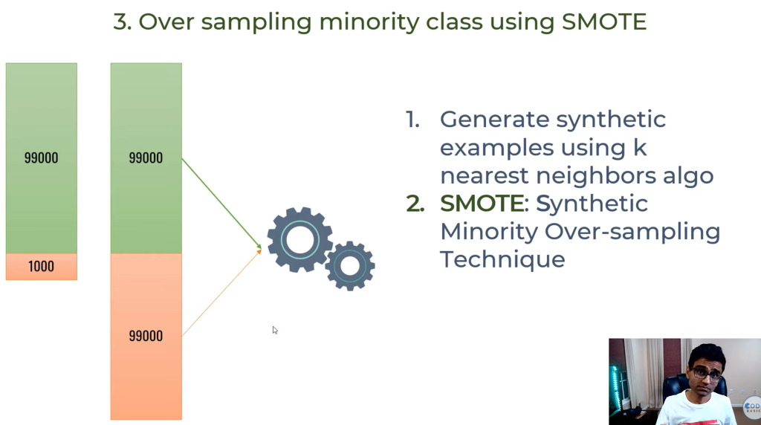

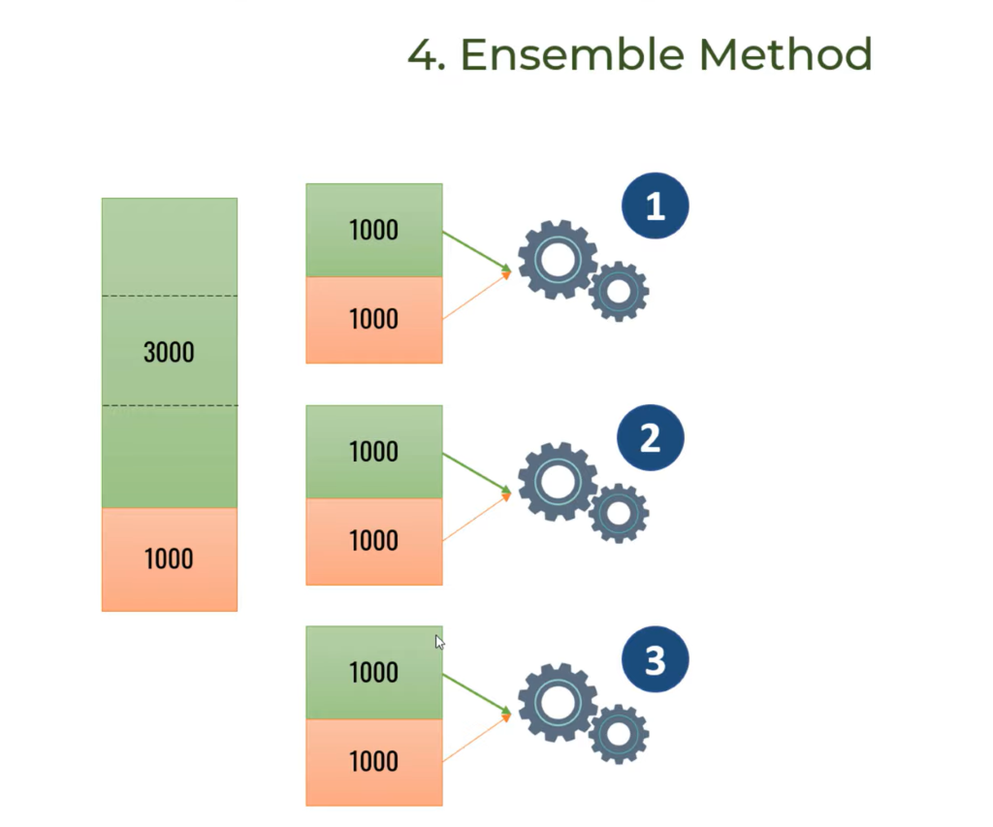

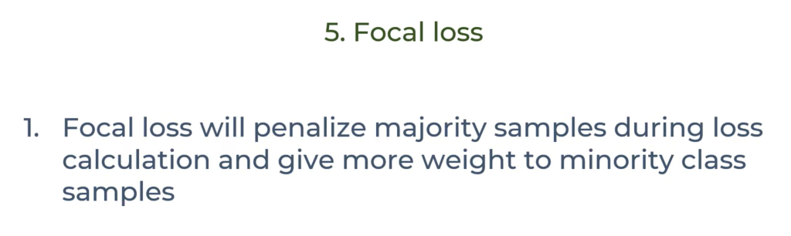

Questions to address before leaving DS.

Sure, here are some tough deep learning questions you might encounter in an interview:

1. **Explain the differences between generative and discriminative models. Provide examples of each and discuss their applications in real-world scenarios.**

2. **Describe the architecture and training process of a Generative Adversarial Network (GAN). How does it work, and what are its potential limitations?**

3. **What are attention mechanisms in deep learning, and how do they improve model performance? Can you provide examples of architectures that utilize attention mechanisms and explain their significance?**

4. **Discuss the challenges and techniques involved in training deep neural networks on limited or small datasets. How would you approach such a problem in practice?**

5. **Explain the concept of transfer learning in deep learning. How does it work, and what are the advantages and disadvantages of using transfer learning compared to training a model from scratch?**

6. **What is the vanishing gradient problem, and how does it affect deep neural networks during training? Can you suggest some techniques to mitigate this issue?**

7. **Describe the differences between traditional computer vision techniques and convolutional neural networks (CNNs). When would you choose one approach over the other, and why?**

8. **Discuss the challenges and potential biases associated with deploying deep learning models in real-world applications, particularly in sensitive domains like healthcare or criminal justice. How would you address these concerns?**

9. **Explain the concept of regularization in the context of deep learning. What are some common regularization techniques, and how do they prevent overfitting?**

10. **Describe the process of hyperparameter tuning in deep learning. What are some strategies or algorithms you would use to optimize hyperparameters efficiently?**

CNN:

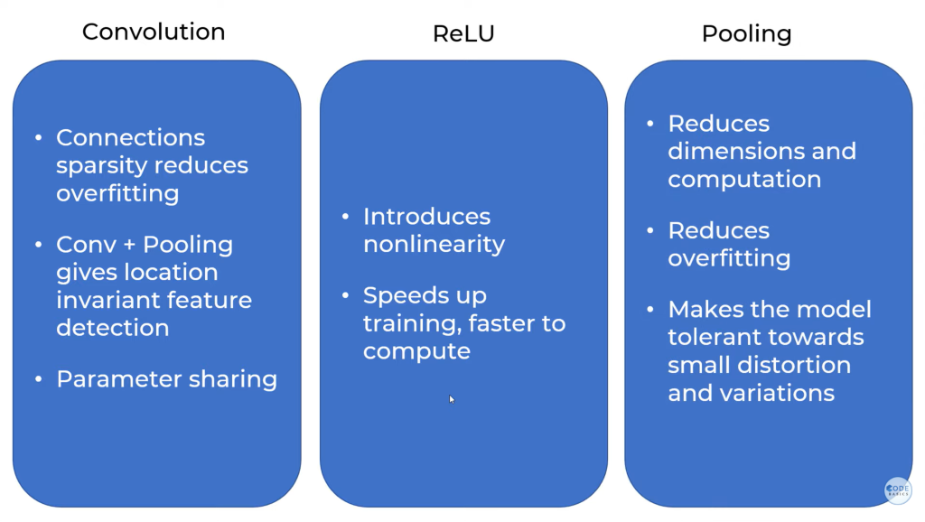

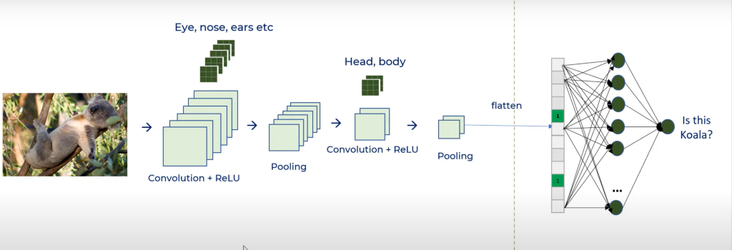

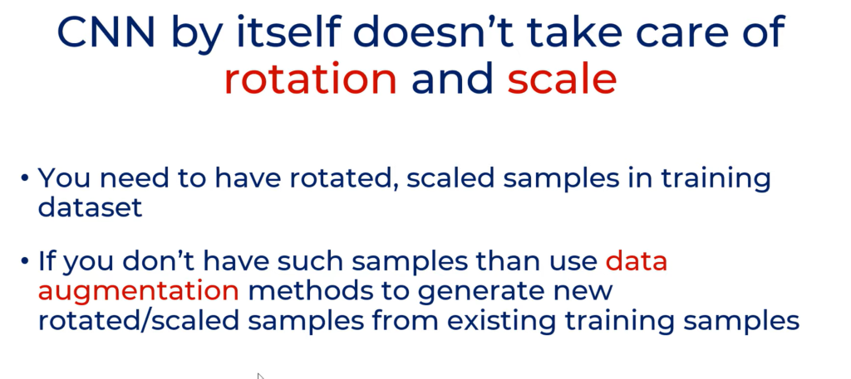

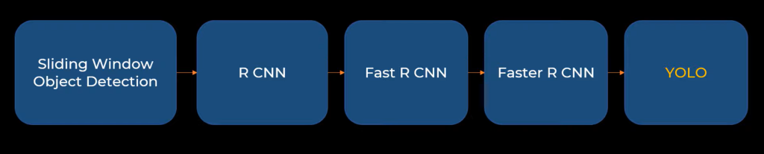

When Y is one hot encoded we use categorical_crossentropy and for normal numeric we use sparse_categorical_crossentropy

Diff between sigmoid and softmax is that softmax will normalize the probabilities, I.e sum of all prob of the neurons will be 1 but for sigmoid it is not necessary.

In a convolutional neural network, pooling layers are applied after the convolutional layer. The main purpose of pooling is to reduce the size of feature maps, which in turn makes computation faster because the number of training parameters is reduced.

Tensorflow hub is ex of transfer learning where you freez the hidden layers except the last layer to get good results in less computation.

Yolo is the object detection algoritham - [What is YOLO algorithm? | Deep Learning Tutorial 31 (Tensorflow, Keras & Python)](https://youtu.be/ag3DLKsl2vk?si=8YpeqzVHvTNdgMa8)

RNN

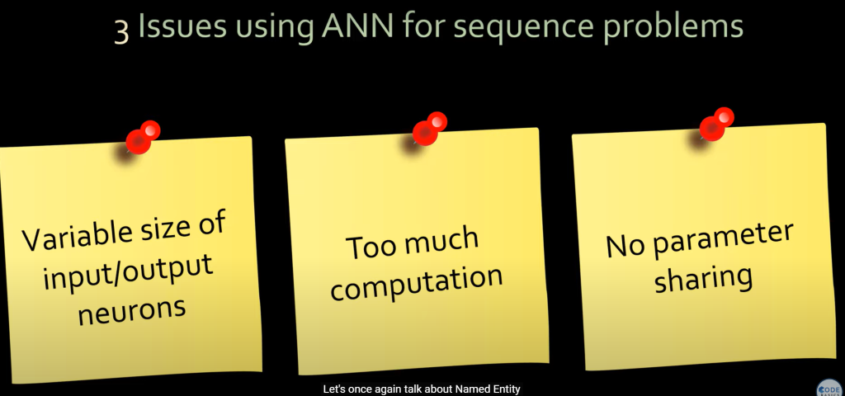

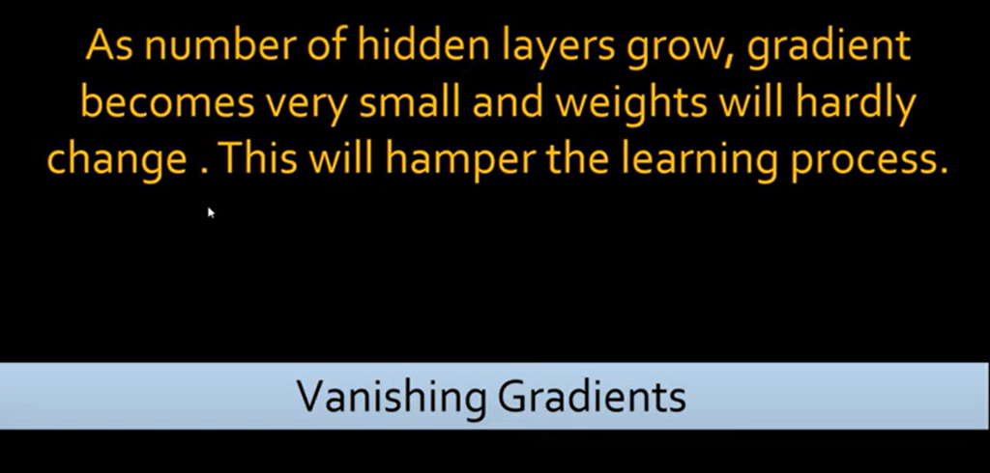

Steps to tackle vanishing GD problem :

* Activation Function Choice:
* Use activation functions with non-vanishing gradients throughout the network. Popular choices include:
* ReLU (Rectified Linear Unit)
* Leaky ReLU (variant of ReLU with a small positive slope for non-zero gradients)
* Weight Initialization:
* Initialize weights in a way that prevents gradients from becoming too small or large. Techniques like Xavier initialization or He initialization can help.
* Gradient Clipping:
* Limit the maximum value of gradients during backpropagation to prevent them from exploding or vanishing completely.
* Residual Networks (ResNets):
* Use a specific network architecture called residual networks (ResNets) that incorporates skip connections. These connections allow the gradients to flow directly from earlier layers to later layers, bypassing the issue of vanishing gradients through multiple layers.

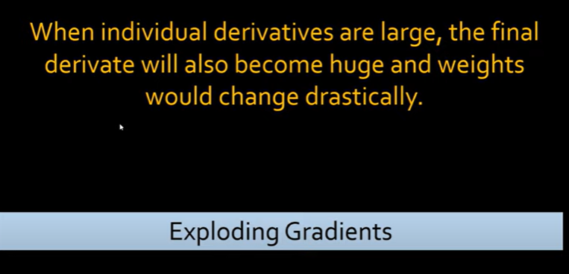

We can cover this problem using GRU or LSTM

LTSM

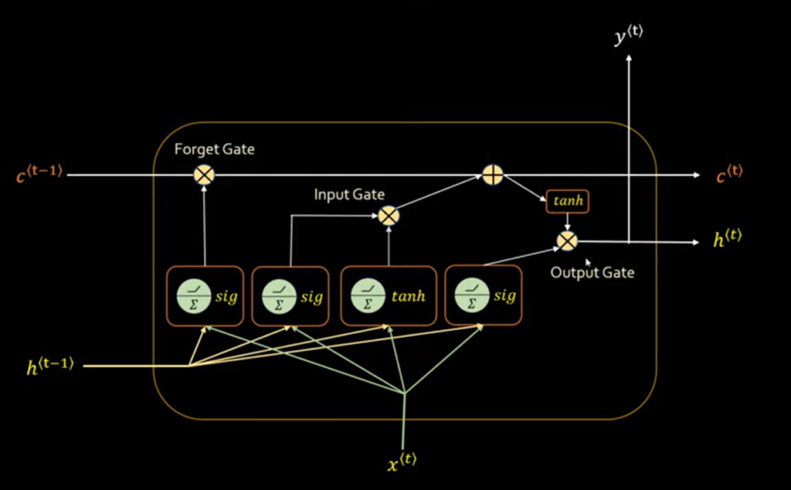

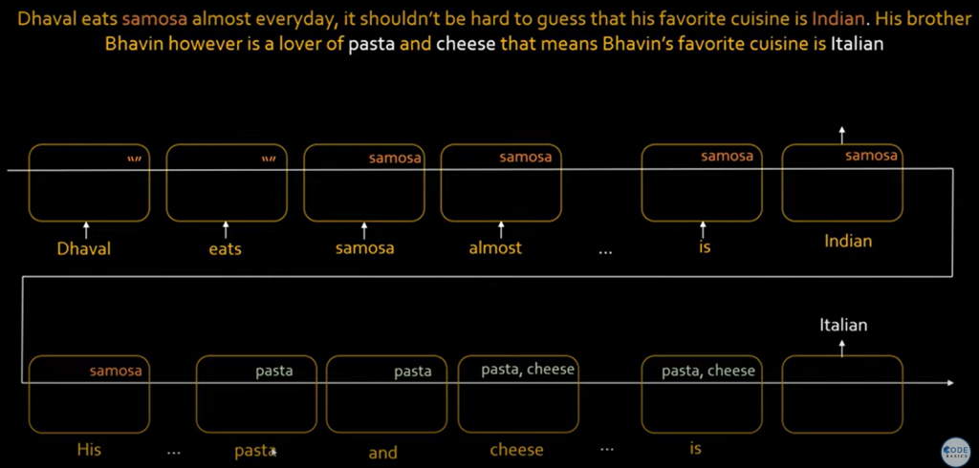

Article to read in free time - <https://colah.github.io/posts/2015-08-Understanding-LSTMs/>

GRU combines short term and long term memory and it is lightweitght then LSTM

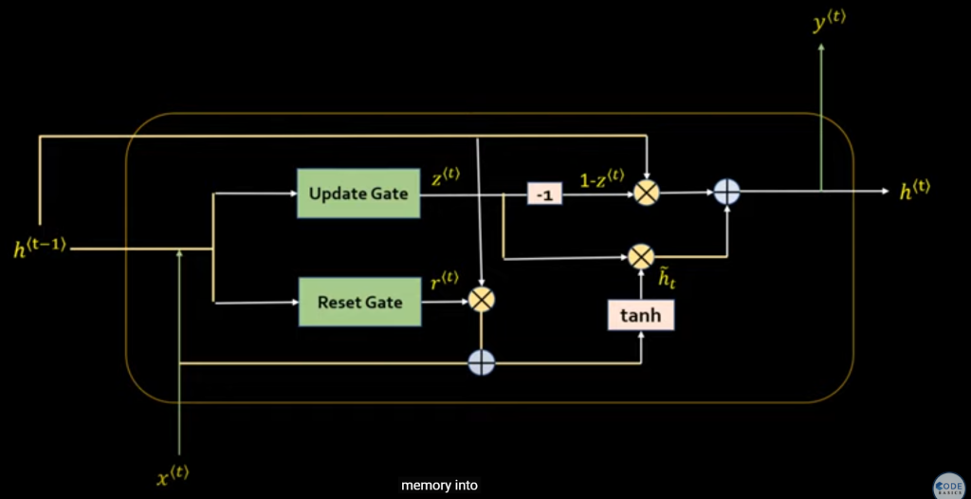

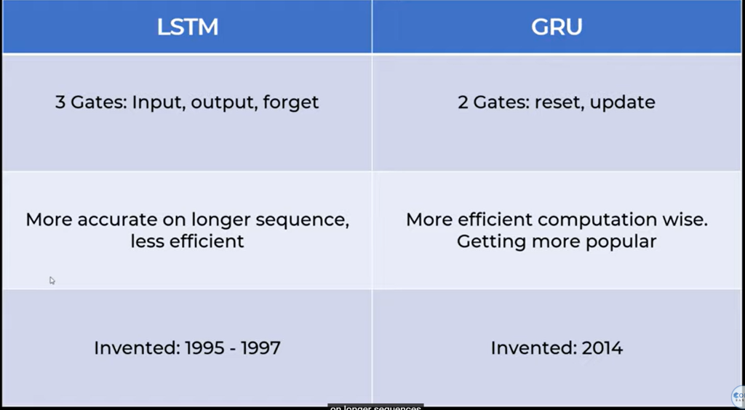

Bidirectional RNN

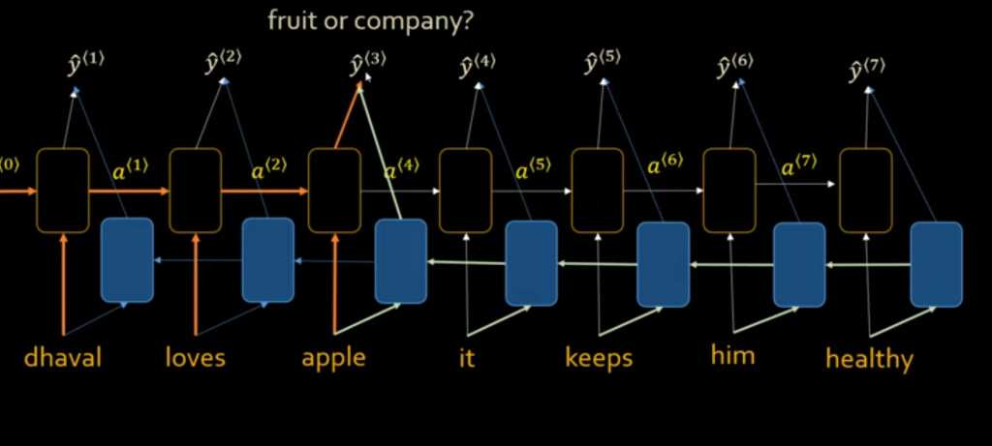

Word embeddings article - <https://machinelearningmastery.com/use-word-embedding-layers-deep-learning-keras/>

Important points

A hyperparameter is a parameter whose value is set before the learning process begins. It determines how a network is trained and the structure of the network (such as the number of hidden units, the learning rate, epochs, etc.).

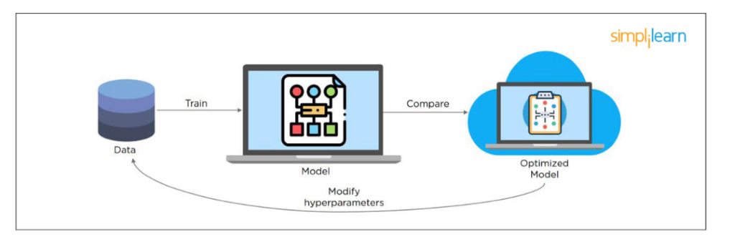

While training an RNN, your slope can become either too small or too large; this makes the training difficult. When the slope is too small, the problem is known as a “Vanishing Gradient.”

To takle this we can choose optimizers correclty.

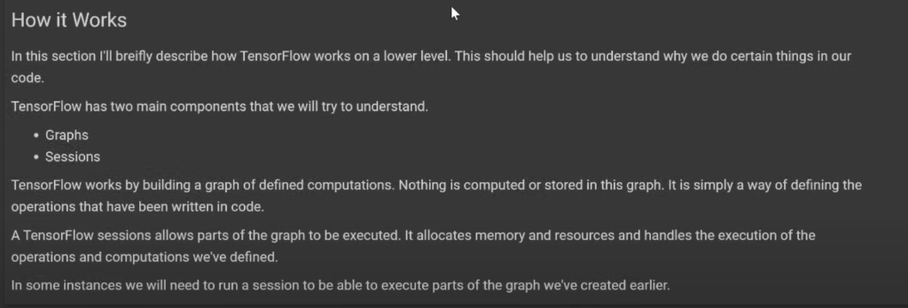

Transformers:

are a distinct architecture for processing sequential data that has largely replaced RNNs for many tasks, especially in natural language processing (NLP).

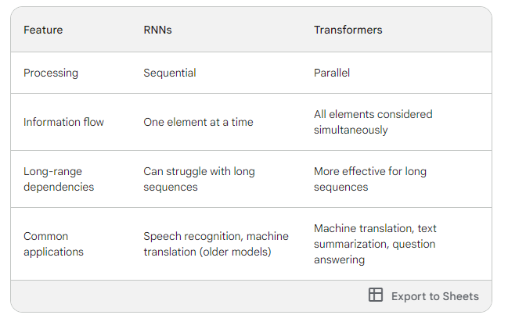

FNN:

Feedforward Neural Network (FNN): Information flows in one direction, from input through hidden layers (if any) to the output layer. There are no loops or cycles in the network.

Backpropagation: This is a training algorithm used in FNNs to adjust the weights between neurons. It compares the network's output with the desired output (ground truth) and propagates the error backwards through the network. Based on this error, the weights are fine-tuned to improve the network's performance in future iterations.

FNNs are often referred to as "vanilla" neural networks because they represent the foundation upon which more complex architectures like convolutional neural networks (CNNs) are built.

GANs

Generative Adversarial Networks (GANs) are a fascinating concept in deep learning that use an adversarial approach to generate new data. Imagine two rivals constantly trying to outdo each other, and that's essentially how GANs work!

Here's a breakdown of GANs:

* **Two Neural Networks in One:** A GAN consists of two deep neural networks locked in competition:
  + **Generator Network (G):** This network acts like an artist, creatively generating new data samples that resemble the training data it's been exposed to.
  + **Discriminator Network (D):** This network acts like a critic, meticulously examining both real data from the training set and the generated data from G. Its goal is to determine whether a data sample is real or fake.
* **The Adversarial Process:** The core idea of GANs lies in this adversarial training.
  + **Generator's Goal:** G constantly tries to improve its forgery skills by generating data that D mistakes for real data. As G gets better, D's job of identifying fakes becomes more challenging.
  + **Discriminator's Goal:** D continuously refines its detection abilities to better distinguish real data from G's creations. As D gets better at spotting fakes, it pushes G to create even more realistic forgeries.
* **The Result:** Through this ongoing competition, both networks become increasingly adept at their roles. Eventually, the generator becomes skilled at creating new data that closely resembles the real data it was trained on.

**Applications of GANs:**

GANs have a wide range of applications, including:

* **Generating realistic images:** Creating new photos, editing existing photos, or even creating entirely new artistic styles.
* **Text generation:** Generating realistic and creative text formats, like poems, code, scripts, or musical pieces.
* **Data augmentation:** Expanding existing datasets by creating new, synthetic data samples, which can be particularly useful when real data is scarce.

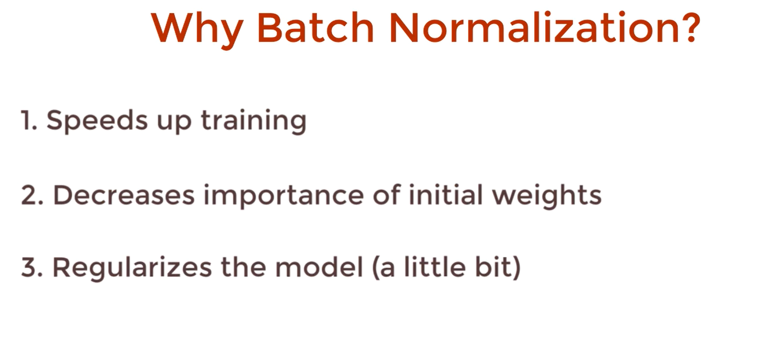

In Adam we use different learning rate for all the features effectively

Batch normalization is a technique used in training deep neural networks. It helps address a challenge called "internal covariate shift"(It essentially means the distribution of data (activations) within a network keeps changing as the network itself learns and adjusts its weights.) which can slow down training. Here's a breakdown of what it does and why it's important:

It can also act as a regularizer

Batch normalization is the technique to improve the performance and stability of neural networks by normalizing the inputs in every layer so that they have mean output activation of zero and standard deviation of one.

We use early stopping callbacks to stop when accuracy is saturated

How to stop training in between:

1. Using callbacks
2. Using ctrl+c and handle this sigint in your code..

Cost vs loss fn

While loss functions quantify the error for individual data points, cost functions provide a global measure of performance across the entire dataset. The terms are often used interchangeably, but it's important to understand their distinct roles in the context of machine learning.

A hyperparameter is a parameter whose value is set before the learning process begins. It determines how a network is trained and the structure of the network (such as the number of hidden units, the learning rate, epochs, etc.).

To combat overfitting and underfitting, you can resample the data to estimate the model accuracy (k-fold cross-validation) and by having a validation dataset to evaluate the model.

A "fully connected layer," also known as a "dense layer,"

Vanishing and Exploding Gradients usually occurs in RNN.

Tensorflow provides both C++ and Python APIs, making it easier to work on and has a faster compilation time compared to other Deep Learning libraries like Keras and Torch. Tensorflow supports both CPU and GPU computing devices.

What are some of the uses of Autoencoders in Deep Learning?

* Autoencoders are used to convert black and white images into colored images.
* Autoencoder helps to extract features and hidden patterns in the data.
* It is also used to reduce the dimensionality of data.
* It can also be used to remove noises from images.

Principle Component Analysis is required to reduce dimensions in data

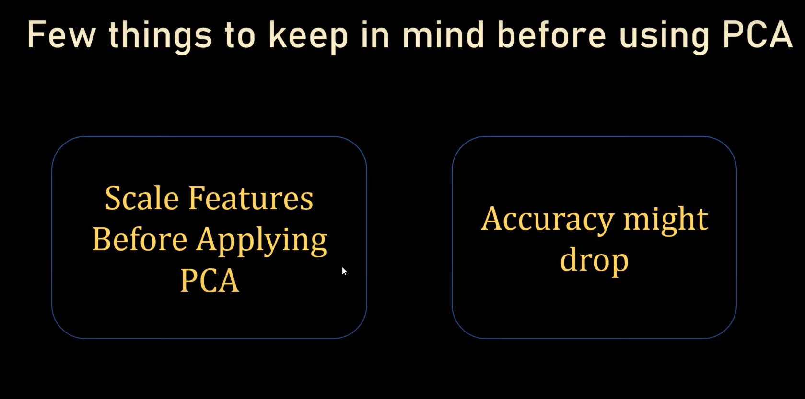

Data Science Lifecycle:

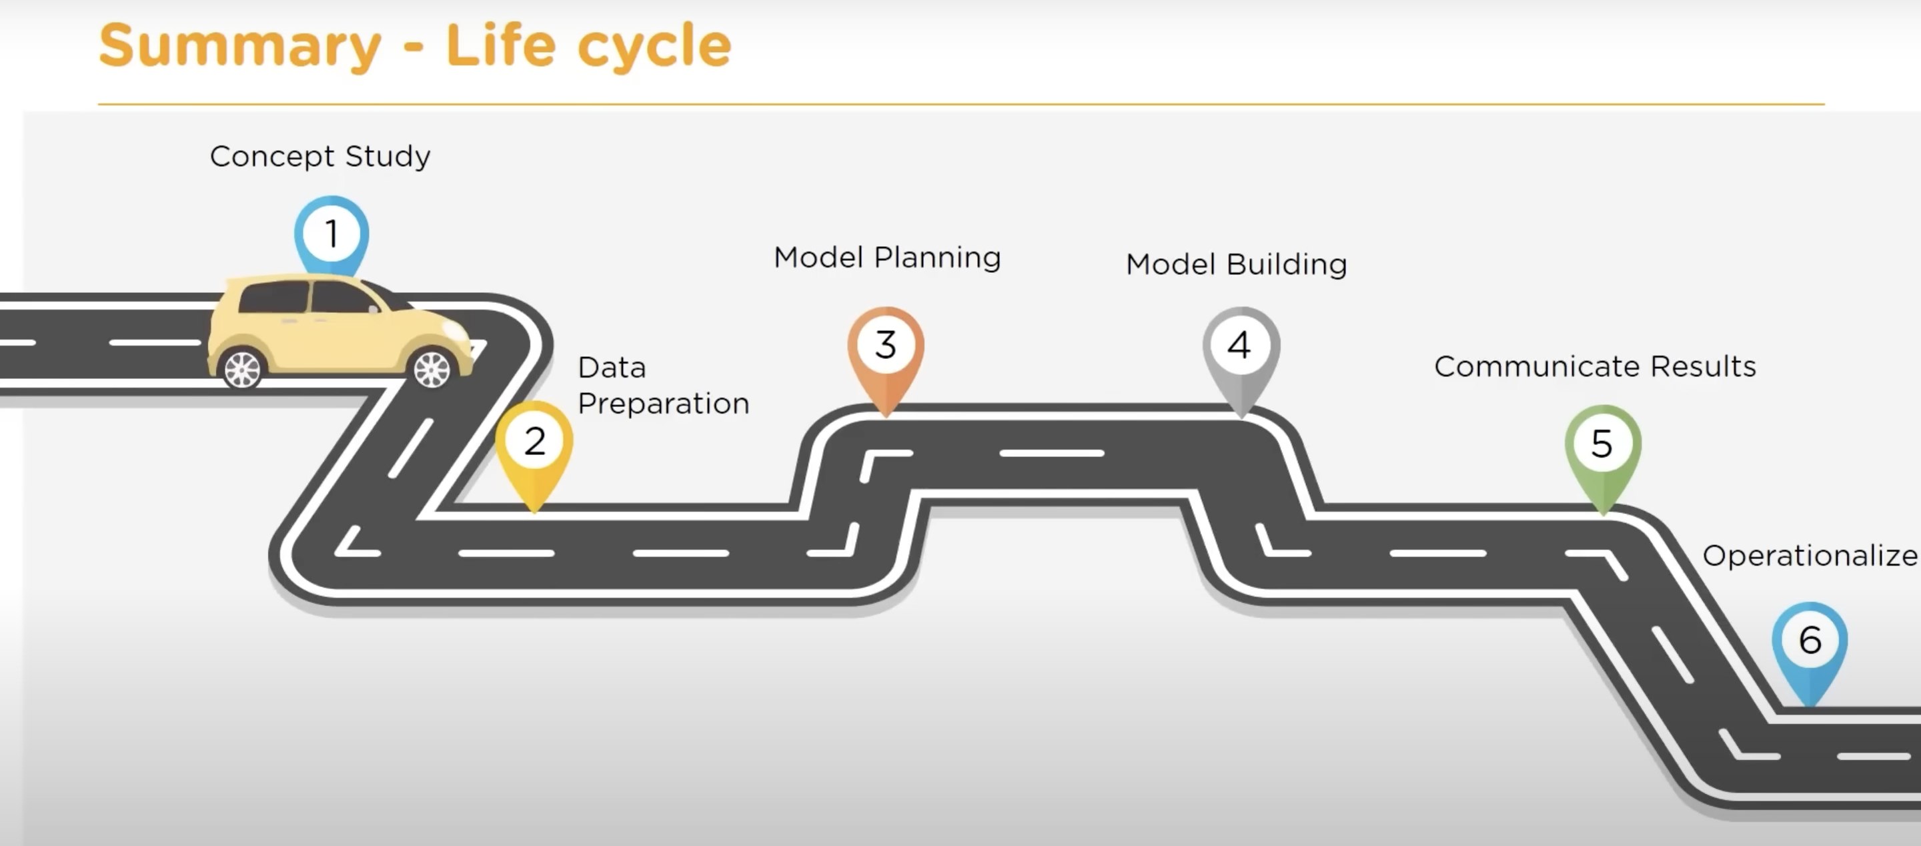

A pipeline in the context of data processing and machine learning refers to a sequence of steps or transformations that are applied to the data in a specific order.

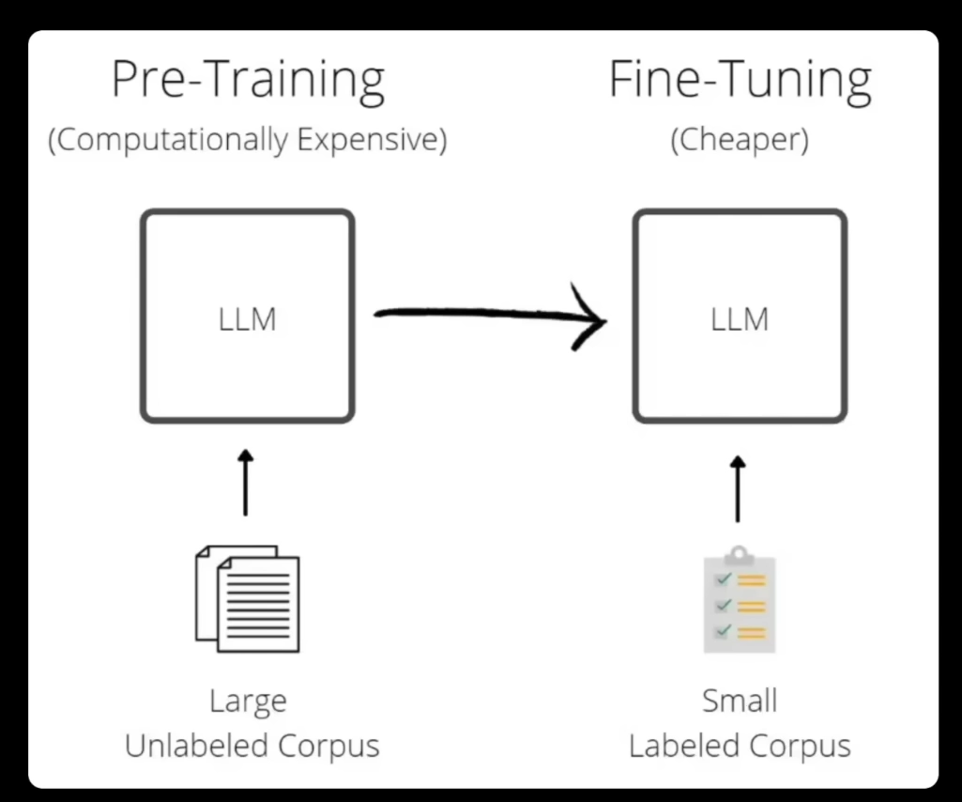

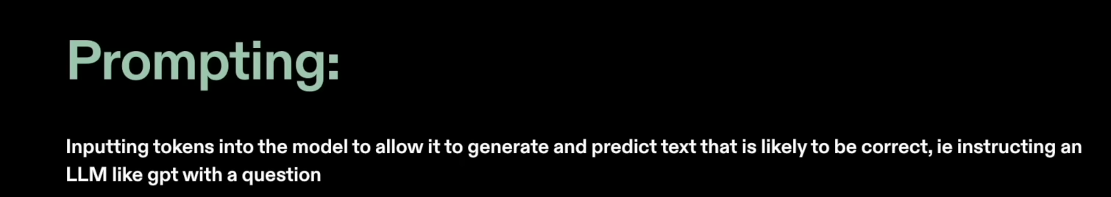

Variance refers to the error introduced by the model's sensitivity to small fluctuations in the training set. It measures how much the model’s predictions would change if it were trained on a different training set.

Bias refers to the error introduced by approximating a real-world problem, which may be complex, by a simplified model. It is the difference between the average prediction of our model and the correct value which we are trying to predict.

Chainlit – package for llm

Deep Learning involves the use of artificial neural networks with many layers (hence "deep") to model complex patterns in data. Deep learning algorithms are capable of automatically learning and extracting high-level features from raw data, making them particularly powerful for tasks involving large and complex datasets.